**Topics: Confidence Intervals**

1. For each of the following statements, indicate whether it is True/False. If false, explain why.
2. The sample size of the survey should at least be a fixed percentage of the population size in order to produce representative results.

Answer:- False,

In order to obtain results that are representative of the population, the survey's sample size should at the very least be a certain proportion of that size.

1. The sampling frame is a list of every item that appears in a survey sample, including those that did not respond to questions.

Answer:- False,

Rather than a list of items that do not respond to the inquiries, the sampling frame refers to a list of items that do.

1. Larger surveys convey a more accurate impression of the population than smaller surveys.

Answer:- True,

Larger surveys use larger samples, which lowers the likelihood of mistakes.

1. *PC Magazine* asked all of its readers to participate in a survey of their satisfaction with different brands of electronics. In the 2004 survey, which was included in an issue of the magazine that year, more than 9000 readers rated the products on a scale from 1 to 10. The magazine reported that the average rating assigned by 225 readers to a Kodak compact digital camera was 7.5. For this product, identify the following:
2. The population
3. The parameter of interest
4. The sampling frame
5. The sample size
6. The sampling design
7. Any potential sources of bias or other problems with the survey or sample

Answer:- A.The population(Readers of the magazine) :- 9000 readers

B. The parameter of interest(Rating of the camera):- 7.5

C.The sampling frame:- all readers of the issues in which the survey appeared.

D.The sample size :- 225 Readers

E.The sampling design :- Voluntarily Interact

F.Survey error refers to errors in the design and implementation of the survey instrument, as well as errors in the interpretation of results.and about the Sample error so this occurs when mistakes are made selecting a sample

1. For each of the following statements, indicate whether it is True/False. If false, explain why.
2. If the 95% confidence interval for the average purchase of customers at a department store is $50 to $110, then $100 is a plausible value for the population mean at this level of confidence.

True, A 95% confidence interval is a set of values that contains the true mean of the population 95% of the time. Because large samples provide much more precision than small samples, the confidence interval is quite narrow when computed from a large sample.

1. If the 95% confidence interval for the number of moviegoers who purchase concessions is 30% to 45%, this means that fewer than half of all moviegoers purchase concessions.

False, the proportion of the moviegoers who do not like to purchase from the concession is more than 50%, the stated claim is found to be false.

1. The 95% Confidence-Interval for *μ* only applies if the sample data are nearly normally distributed.

False, With a large enough​ sample, the central limit theorem implies a normal sampling distribution regardless of the distribution of the data.

1. What are the chances that ?
2. ¼
3. ½
4. ¾
5. 1

Answer = If X is less than the population mean (), the likelihood of > X is greater than half.

If X equals, then the probability of > X is exactly half.

If X is bigger than, the chance of > X is less than 1/2.

Based On the Observation the Answer is : B. ½

1. In January 2005, a company that monitors Internet traffic (WebSideStory) reported that its sampling revealed that the Mozilla Firefox browser launched in 2004 had grabbed a 4.6% share of the market.
2. If the sample were based on 2,000 users, could Microsoft conclude that Mozilla has a less than 5% share of the market?

Answer:- As (p_value = 0.2058) > (α = 0.05) ; Accept Null Hypothesis i.e. Mozilla market share > 5% Thus, Microsoft can not conclude that Mozilla has a less than 5% share of the market.

1. WebSideStory claims that its sample includes all the daily Internet users. If that’s the case, then can Microsoft conclude that Mozilla has a less than 5% share of the market?

Answer:- We are told that WebSideStory claims to have a sample of all daily Internet users. This means that 4.6% is the population percentage. When compared to Microsoft's claim that Mozilla has less than 5% of the market, this is correct.

As a result, we can conclude that Mozilla controls less than 5% of the market.

1. A book publisher monitors the size of shipments of its textbooks to university bookstores. For a sample of texts used at various schools, the 95% confidence interval for the size of the shipment was 250 ± 45 books. Which, if any, of the following interpretations of this interval are correct?
2. All shipments are between 205 and 295 books.

Incorrect

1. 95% of shipments are between 205 and 295 books.

Correct

1. The procedure that produced this interval generates ranges that hold the population mean for 95% of samples.

Correct

1. If we get another sample, then we can be 95% sure that the mean of this second sample is between 205 and 295.

Correct

1. We can be 95% confident that the range 160 to 340 holds the population mean.

Incorrect

1. Which is shorter: a 95% *z*-interval or a 95% *t*-interval for *μ* if we know that σ =s?
2. The z-interval is shorter
3. The t-interval is shorter
4. Both are equal
5. We cannot say

Answer: -A. **The z-interval is shorter**, because t-critical is greater than z-critical, the 95% confidence interval for mean is shorter for z-interval. Yes, because t-critical value cannot be less than z-critical value, z-interval is always shorter.

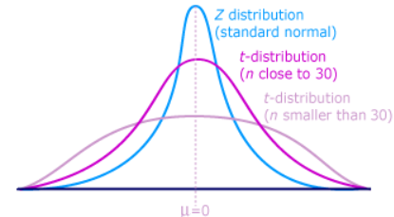

Questions 8 and 9 are based on the following: To prepare a report on the economy, analysts need to estimate the percentage of businesses that plan to hire additional employees in the next 60 days.

1. How many randomly selected employers (minimum number) must we contact in order to guarantee a margin of error of no more than 4% (at 95% confidence)?
2. 600
3. 400
4. 550
5. 1000

Answer:- Hence, n = Number of employe

suppose $\underline{p}=0.5$

Margin of error = 0.04

For 95% confidence interval, the critical value Z= 1.96 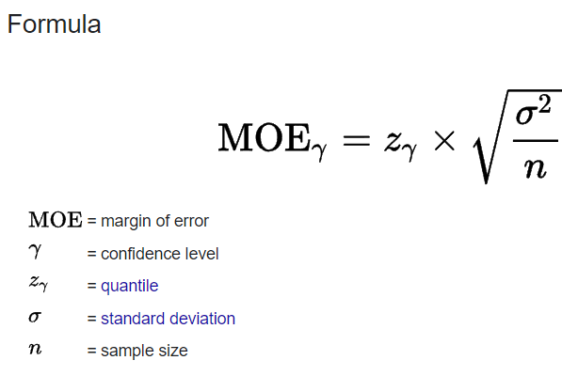

0.04 = 1.96 $\sqrt{\frac{0.5*0*5}{n}}$* = n= $\frac{1.96^{2}*0.5*0.5}{0.4^{2}}$ = $\frac{0.9604}{0.0016}$ =600

Hence, A is the correct answer

Suppose we want the above margin of error to be based on a 98% confidence level. What sample size (minimum) must we now use?

1. 1000
2. 757
3. 848
4. 543

For 98% Confidence interval the critical value Z= 2.32

0.04 = 2.326 $\sqrt{\frac{0.5*0*5}{n}}$* = $\frac{2.3{26}^{2}*0.5*0.5}{0.4^{2}}$ = $\frac{1.3525}{0.0016}$ = 845.38

Hence, C is the correct answer